

Telecommunications Cabling system Specification

**Newcastle University IT Service**

**Newcastle University**

**Claremont Road**

**NE1 7RU**

|  |  |  |  |  |
| --- | --- | --- | --- | --- |
| iSSUE: | vERSION 6.00 | aUTHOR: | A FISHER | dATE 18:07:2018 |

**CONTENTS PAGE**

**Section 1 GENERAL OVERVIEW**

1.01 Introduction 3

1.02 Scope of Works 3

1.03 Compliance 3

1.04 Performance Requirements 4

**Section 2 DESIGN PARAMETERS**

2.01 Components 4

2.02 Physical Requirements 4

2.03 Cable Separation 4

2.04 Cable Tray, Basket and Trunking 5

2.05 Class E/Ea UTP Channels 5

2.06 Wi-Fi Cabling and Installation 6

2.07 Optical Fibre requirements 6 2.08 Patch Leads 7

2.09 Equipment Cabinets 8

2.09.1Rack Mount Freestanding Cabinets 8

2.09.2Rack Mount Wall Cabinets 8

2.10 Patch Panel & Cable Management 8

2.11 IT Network (data/patch/distribution) Room Power and Cooling 8

2.11.1 Introduction 8

2.11.2 Lighting 9

2.11.3 Ventilation 9

2.11.4 Power 9

2.11.5 Earthing 9

2.11.6 Access Control 9

2.12 Voice Multicore cables Copper 10

2.12.1 Introduction 10

2.12.2 Installation 10

2.12.3 Cable Routes 10

2.12.4 Segregation from Other Services 10

2.12.5 Terminations 10

2.12.6 Testing10

2.12.7 DECT Base Stations 11

## Section 3 LABELLING

3.01 UTP Link Identification 12

3.02 Fibre Link Identification 13

3.03 Wi-Fi identification 13 3.04 WAP Identification 13

3.05 Copper backbone identification 13

**Section 4** **WARRANTY AND TESTING**

4.01 System Warranty 14

4.02 Compliance Testing 15-16

4.03 Telecommunications Cabling System Documentation 16

**Section 5 CONTRACT AWARDS**

5.01 Measured Term Contract for Telephony and Data Works 17

5.02 Table of Lots and awarded contractors 17

**Section 6 HANDOVER & ACCEPTANCE**

Appendix 1 - Handover and acceptance checklists 18- 19

Appendix 2 - Cabinet layout diagrams 20

Appendix 3 – High Density Patching Example 21

Document History 22

# SECTION 1 GENERAL OVERVIEW

## Introduction

It is a mandatory requirement that the Telecommunications Cabling System described in this specification is installed by a specialist Telecommunications Cabling System Contractor who has the appropriate approved installer status and can provide the system warranty for the manufacturer of the equipment that they are supplying.

The University has a number of cabling systems on site and they can be found in section 4.01. It is expected that unless instructed by the University that the existing cable schemes will be extended with the appropriate manufacturer’s cable/components where available, and should be provided with independent 3rd party verification of the system at Component Level. The exception to this is for new build, contractors must ensure that the preferred cabling manufacturer (Connectix Cabling Systems) is proposed, and that valid Connectix Approved Installer (CAI) status is provided with all tender submissions.

The cabling system shall be backed by a minimum of a 25 year System Warranty as detailed in the specification. The system warranty shall be facilitated by the Contractor and be established between the Customer and the cabling system Manufacturer

**Non-compliance of this cabling standard will result in installations being rejected and replaced at the contractor’s expense**.

* 1. **Scope of Works**

This specification covers the supply, installation and commissioning of a Telecommunications Cabling System and will include the following components:

1. Horizontal Infrastructure (Connectix Category 6A U/FTP).
2. Backbone Infrastructure (Connectix Optical Fibre OS1/OS2 and/or OM3/OM4).
3. Cooper Access Equipment, racks and frames.
4. Termination frames and panels.
5. Multi-purpose Telecommunication Outlets.
6. Supply of drop cables to connect horizontal cabling to connect network services.
7. Generation of base line patching schedules.
8. Documentation and submissions.
   1. **Compliance**

The Telecommunications Cabling System shall be compliant to the most current versions of the following standards:

BS6701 A1 : 2017 (master standard)

EN 50310

EN 50173-1

EN 50174-1, 2, 3

EN 50346

BS 7718 (Code of practice for the installation of fibre optic cabling)

BS 7671 IEE Wiring Regulations

BS 4678

Application Performance and Component Performance guarantees shall be supplied for the installed cabling system for all performance classes up to, and including, Class Ea operation over U/FTP cable and all applicable classes for optical fibre channels.

The system warranty shall comply as per section 4.01

**1.04** **Performance Requirements**

The Telecommunications Cabling System shall, for the performance classes specified for installation, support all existing and future applications approved for operation over optical fibre or copper UTP Channels by either the ISO, IEEE, ATM Forum, ANSI or any standards body, or users forum, that specify operation over copper UTP cable or optical fibre cable compliant with the BSI/CENELEC standard BS EN 50173 (Information technology – Generic cabling system).

## SECTION 2 DESIGN PARAMETERS

**2.01 Components**

All of the Structured Telecommunications Cabling System components must be chosen to suit their working environment, and their installation or use must not contravene any national or local Building Regulation, Health and Safety Regulation or Fire Regulation current at the time of installation

**2.02 Physical Requirements**

The Contractor shall ensure that the following physical requirements are met:

Cable shall be installed above fire-sprinkler and systems and shall not be attached to the

System or any ancillary equipment or hardware.

The cabling system and support hardware shall be installed so that it does not obscure any

valves, fire alarm conduit boxes, or other control devices. Cable containment must be used

to support all cables and shall be in compliance with the standards referenced by this

document and the installation requirements of the cabling system warranty.

Module Faceplates are to be selected following consultation with the nominated Estate Support Service (ESS) Project Manager and the appointed M&E contractor to ensure they blend in with the electrical faceplate profile and décor of the building. Module faceplates shall not show company names, company contact details, company logos or any other information related to the installer of the structured cabling.

**2.03 Cable Separation**

The following minimum separation between metallic telecommunications UTP data cables and ac electrical power cables shall be observed, however, standards or warranty compliance may require wider separation between U/UTP, or U/FTP cables and power circuits:

A minimum separation of 3 metres shall be observed between telecommunications UTP data cables, and ac electrical cables operating at voltages greater than 480Vrms.

Unless completely enclosed in well earthed steel trunking the minimum cable separation between copper UTP or FTP cables and AC electrical power cables and fittings carrying less than 480Vrms shall be whichever is the greater of the following as specified in the ISO/IEC-11801 standard, as specified by the warranty installation requirements or listed in Section 9

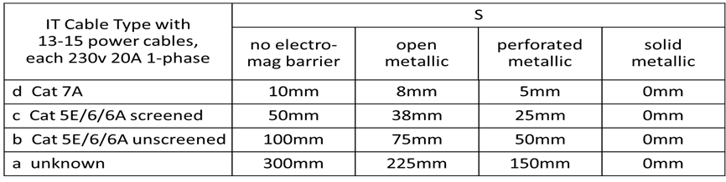

A minimum separation of 160 mm shall be observed between telecommunications UTP data cables and fluorescent or neon lamps.

**2.04 Cable Tray, Basket and Trunking**

Where cable tray or cable basket support is required the size fitted must leave at least 50% capacity for additional future cable requirements.

When installing cable tray and brackets they must be post galvanised steel, all cut edges must be smoothed and no sharp edges or non-flush jointing plates are to remain.

When installing cable basket, only bright zinc plated wire basket may be used, Cut ends of the basket wire must be cut flush with nearest weld joint and smoothed or covered with PVC protective capping, this also applies to any basket jointing fitments.

All cable support products and components must be supplied from manufacturer and not manufactured on-site during installations. All bend requirements must utilise the appropriate and correct bend components as recommended by manufacturer and must not exceed recommended or specified bend radius for the cable type being fitted.

Bundles of up to 24 U/UTP or U/FTP cables must be secured with cable fastening ties to a pressure which will not crush the outer cable jacket. The exposed cable tie must be cut flush at 90 degrees with the fastener latch of each cable tie so no sharp edges remain.

Under no circumstances will U/UTP cable be run alongside electrical supply cable. Minimum separation distances are specified in Section 2.03.

**2.05 Class E/Ea U/UTP and U/FTP Channels.**

Consolidation Point connections shall not be used except in areas were their use has been clearly sanctioned and a written specification has been issued. All Consolidation Point components must be approved by Newcastle University NUIT Telecoms & Cabling Team.

Telecommunication outlets (TOs) shall be presented as either single or twin outlets on single gang faceplates, as specified, in the numbers and at the positions shown on the contract specification drawings.

The Contractor shall install the specified and agreed number of Links to work area telecommunication outlets.The telecommunications outlets shall be cabled from the network distribution rooms as instructed

Transition point connections shall not be used in any Permanent Link. The cable between a work area telecommunications outlet and equipment room interconnect patch panel shall be a single, uninterrupted, four pair, 100 ohm U/UTP or U/FTP cable.

In the network distribution rooms the Class E/Ea Channels shall be presented on 1U high 24x socket panel unless otherwise instructed by Newcastle University NUIT Telecoms & Cabling Team

**Table A UTP Data Outlet Distribution and Totals**

|  |  |
| --- | --- |
| **Building Name** | **Data Outlets** |
|  |  |
| **CAT6a Data Outlets** | **0** |
| **WiFi Outlets** | **0** |
| **Information Screen Outlets** | **0** |
| **Access Control Outlets** | **0** |
|  |  |
| **Total Class E/Ea Channels** | **0** |

**NOTE: RECOVERY OF CABLING IN EXISTING INSTALLATIONS**

For areas that are being refurbished and already have structured cabling installed the contractor shall recover the existing data cabling between the wall outlet and the communications room patch panel.

Recovered outlet numbers shall be recorded and provided to NUIT.

**2.06 Wi-Fi Cabling and Installation**

Work area data outlets (TOs) identified on drawings as being installed for Wireless Ethernet Access Base Stations (Wi-Fi) shall be installed at a high level (above 1.8 metres). In the absence of specific instructions for any such data outlet and if the ceiling is a suspended type with metal framing supporting removable tiles, and no more than 3000mm high, then mount the data outlet just above the suspended ceiling, otherwise mount at around 2400mm from floor level. Please note that lecture theatres are an exception and guidance shall be sought, for example; if a lecture theatre has raked seating the Access Base Stations (Wi-Fi) would be mounted high and at the front to avoid excessive radio signal attenuation. Cabling for Wi-Fi outlets shall be presented on the data cabinet on a separate dedicated 1U patch panel above the voice tie cabling and be numbered separately and labelling accordingly W01, W02, and W03 etc.

Mounting brackets for Access Base Stations (Wi-Fi) will be issued by NUIT and shall be fitted by the contractor using the appropriate, non-permanent fixings for the mounting surface. For example, wall plugs and screws for masonry, screws into plinths for ceiling tiles etc.

No permanent fixing method such as mastic or bonding compound shall be used under any circumstances.

## 2.07 Optical Fibre requirements

|  |  |  |  |
| --- | --- | --- | --- |
| **Source** | **Fibre type** | **Number of cores** | **Destination** |
| Eg. Claremont Tower M3 | SM | 48 | Level One Equipment Room |
| Level One Equipment Room | SM | 48 | Level Three Equipment Room |

All optical fibre connector terminations shall comprise a manufactured connector and pigtail assembly fusion spliced to an optical fibre cable core. All optical fibre connector pigtail assemblies shall be supplied by a recognised manufacturer of optical fibre patch leads and pigtailed connectors.

All singlemode optical fibres shall be terminated in blue DUPLEX LC connectors.

The return loss of singlemode connectors shall be better than -40dB.

APC finish connectors shall not be used.

Mechanical optical fibre splices shall not be used.

Field terminated optical fibre connectors shall not be used.

Unless stated otherwise the Contractor shall terminate all fibres using the connectors and method already specified and shall mount the connectors only on purpose designed optical fibre patch panel assemblies. The cable entry gland(s) shall only be to the rear or side of any optical fibre patch panel assembly. The optical fibre patch panels shall be positioned in the equipment cabinets as shown in the contractor specification drawings. See the clause titled ‘Special Requirements’ for details of the allowed splicing, termination methods and connector types.

## 2.08 Patch Leads

The Contractor shall provide flexible, booted UTP patch leads, complete with a latch protector from the same cabling system manufacturer as the patch panels and cabling. The patch leads supplied shall be compatible with the Class E/Ea Permanent Links and meet in full the Channel requirements of the cabling system warranty and capable of 1000BASE-T (Gigabit) operation

Quantities will match the total number of Class E/Ea outlets to be installed within the Data Network Room at lengths appropriate to the type of cabinet and patching method used **PLUS** the number of outlets installed throughout the building at appropriate lengths plus 10% of overall figure

All **field** and **cabinet** UTP patch leads for normal data patching shall be **GREY or WHITE**

All **cabinet** UTP patch leads for the Telephony system shall be **ORANGE**

All **cabinet** UTP patch leads for Wireless Access Points (WAP) shall be **YELLOW**

All **cabinet** UTP patch leads for Student Attendance Monitoring Systems shall be **PURPLE**

**2.09 Equipment Cabinets**

**2.09.1 Rack Mount Freestanding Cabinets**

The Contractor shall supply free-standing 19 inch rack mount cabinets to the following specification.

**Cooper B-Line Access** Data Cabinets shall be used in all IT Distribution Rooms. Unless stated otherwise the cabinets shall be 47U high.

Cabinets for a **SINGLE** cabinet installation shall be 800mm wide and 675mm deep, installations of **TWO** or **MORE** cabinets shall be 600mm wide and 675mm deep UNLESS specified by NUIT as requiring a **HIGH DENSITY** patching approach as shown in **Appendix 3**

All cabinets shall be supported on jacking feet and fitted with the manufacturer’s standard plinth. Side panels shall be fitted to single cabinets and to both ends of a row of cabinets where used. Cabinets arranged in a row shall be joined using the manufacturers baying kit and electrically bonded using the manufacturer’s earth continuity kit.

Fully vented (perforated) steel front and rear doors shall be provided for each cabinet, both with locks, and the same key for all cabinets.

The Contractor shall provide (supply and fit) two vertical mounting mains power distribution units to each cabinet which is to house equipment to the following specification; 15 way (min) socket strip to accept 13A BS1363 plugs, with 13 amp rated, 5 metre flexible lead fitted with a 16A commando plug.

The Contractor shall set back the front 19inch mounting rack in floor standing cabinets to allow the front door to close with 100mm deep vertical management installed.

Cabinets shall be installed a minimum clearance at both front and rear of 0.7m from any wall or projection to allow access.

Cabinet/s shall be earthed to a suitable good clean earth earthing point with a lugged 6.0mm² (minimum) Green / Yellow PVC jacketed cable terminated in the cabinet to a suitable good clean earth point.

**2.09.2 Rack Mount Wall Cabinets**

The Contractor shall supply wall mounted 19 inch rack mount cabinets to the following specification.

Wall mounted cabinets shall be adequately sized to allow for the accommodation of the required equipment (MINIMUM of 12U) and an additional allowance of approximately 30% made to accommodate future expansion. The physical size of the cabinet shall be calculated to ensure adequate space allocation. One twin switched 13A mains power socket compatible with BS1363 plugs shall be installed adjacent to the wall mounted cabinet on its own radial circuit back to the distribution board and clearly marked “IT Network Cabinet” at the power DB. The Contractor shall provide (supply and fit) one 5 way horizontal mounting mains power distribution units to the following specification; 5 way socket strip to accept 13A BS1363 plugs, with 13 amp rated flexible lead of sufficient length to reach the mains socket provided for the wall box and fitted with a 13A BS1363 fused plug.

Wall mounted cabinets shall be installed to allow a minimum of a 1.2m radius around the front of the cabinet to allow free and easy access

Wall mounted cabinets shall be securely fastened to a solid wall

Wall mounted cabinets must be housed in a suitable secure Network Room.

**2.10 Patch Panel & Cable Management**

The Contractor shall install the patch panels and provide cable management to the following specification. The patch panels shall be positioned in the equipment room cabinets as shown in the specification drawings.

The UTP (RJ45) interconnect patch panels shall comprise 1U panels of 24x sockets interleaved with 1U panels of horizontal cable management with nominally 65mm deep rings (alternating 1U cable management panels and 1U 24x connector panels).

**The contractor shall install M6 caged nuts in standard 1U configuration in the whole of the front 19inch rack of all the cabinets, and supply an equivalent number of M6 steel pan/button head 15mm long screws.**

The contractor shall install cable management in the cabinet reserved for equipment at the positions they are installed for the UTP patch panels in the adjacent right hand side cabinet.

The contractor shall supply additional 1U horizontal cable management panels and vertical cable management rings for each IT distribution room. These will be installed by others when the network switches are installed.

The Contractor shall provide one 100x75mm (min dimensions) single ring vertical cable management ring for each 6U, 24x connector panel and mount them on the right hand side only of the UTP and optical fibre patch panels at each 1U, 24x RJ45 or optical fibre connector panel. The contractor shall ensure that the front cabinet doors can be closed with the vertical rings installed.

# 2.11 IT Network (data/patch/distribution) Room Power and Cooling

**2.11.1 Introduction**

The room in which the cabinets/racks are housed shall meet the following specification and shall be dedicated for the use of housing NUIT equipment only and will not be shared with other services. The room size must be designed to allow sufficient space for the required number of cabinets to be installed. Access is required to both the front and rear of the cabinets with a minimum 0.7m at the front and back. For new builds the floor to ceiling height shall be no less than 2.6 metres and false ceilings are not permitted.

**2.11.2 Lighting**

The lighting shall be a minimum of 500 lux (50 foot candles). Light fittings shall be located a minimum of 2.6 metres from the finished floor level. When an existing room is being outfitted and the ceiling height does not meet the requirement above then the customer shall be notified.

A minimum of one light fitting with an emergency light situated above the main exit.

**2.11.3 Ventilation**

Positive air pressure to be maintained to prevent ingress of dust into the room, this condition may be relaxed if an existing room is to be used.

A minimum of one air change per hour is required if the room has no forced air ventilation or air cooling unit. The room free air ambient temperature should normally not exceed 25 deg Celsius and must never exceed 30 deg Celsius. If power dissipation figures are not provided then the network equipment dissipation in the room can be roughly estimated as follows; 2000 watts for each cabinet in which equipment is to be mounted, plus 2200 watts for router & distribution switches. This includes an allowance for PoE switches assuming a maximum of 10% of the data outlets may be used for IP telephones or wireless base stations.

**2.11.4 Power**

A minimum of one easily accessible twin 13A power socket is required for maintenance and inspection purposes only. Plus 1 16Amp commando socket per cabinet from a dedicated power supply.

Unswitched 13A mains power sockets, and unswitched IEC 60309 mains power sockets, shall be installed adjacent to the floor standing network equipment cabinets, that is mount the socket within 2 metres of the equipment cabinet it is intended to serve.

For each cabinet, one twin un-switched 13A mains power socket compatible with BS1363 plugs, and one un-switched switched IEC 60309 16A/240v socket (plus mating plug), ground position 6, P+N+E (2P+E) is required.

In addition, for the end cabinet on the right (front view) of the row only, one extra switched IEC 60309 16A/240v socket (plus mating plug), ground position 6, P+N+E (2P+E) shall be provided.

All single and twin sockets shall be on separate radial circuits with suitably rated wiring and circuit breakers and at the Distribution Board all shall be clearly marked “IT Network Room {plus room No}”, dedicated distribution boards are preferred.

All the mains supply power circuits supplying the equipment cabinets shall be controlled by individual local double pole contactors and the contactors shall be sited to be easily accessible and clearly visible to anyone working on the equipment cabinets, each contactor shall be clearly labelled.

**2.11.5** **Earthing**

The facility shall be equipped with a Telecommunications Bonding Backbone (TBB). This backbone shall be used to ground all telecommunications cable shields, equipment, racks, cabinets, raceways, and other associated hardware that has the potential for acting as a current-carrying conductor. The TBB shall be installed independently of the building electrical ground.

**2.11.6 Access Control**

All network rooms will be protected by the existing NUIT University Smartcard System.

No new or third party access control systems will be accepted.

**2.12 Copper Backbone (Voice tie) cabling**

**2.12.1 Introduction**

This Section details the required standards for the Copper Backbone (Voice tie) cabling.

Multi-core voice backbone cables shall be installed to interconnect the voice ICD cabling scheme with the structure cabling scheme. Cables provided for voice communications purposes shall be of the CW 1308 (LSOH) or CW 1308B (LSOH) type with a conductor diameter of 0.5 mm. As a general rule 50, 100 and 200 pair cables should be used as standard.

**2.12.2 Installation**

All cabling shall be run in suitable containment and neatly clipped at regular intervals.

All cabling shall be installed into appropriate cable tray, basket tray or trunking, (in accordance with the manufacturer’s instructions). Particular care shall be taken in not kinking or bending cabling past acceptable radius curves. Cables shall not be subjected to any weight, tension, heat or other pressures / forces. The weight of the cabling shall be supported by the tray-work and be clipped at regular intervals.

Sufficient cable length shall be left at each end of the cable for 3 future re-terminations.

**2.12.3 Cable Routes**

All cable / containment routes shall be planned and installed within guidelines set out in European Standard EN50174.

All cable routes shall be agreed with the University prior to commencement of installation.

**2.12.4 Segregation from Other Services**

Special notice shall be made in ensuring that all cables are kept at a suitable distance from other services to avoid “EM type” and other interference (In accordance is European Standard EN50174 and British Standard BS6701 A1 : 2017)

All cabling must be run away from other services such as mains power and heating pipes that may cause interference or damage to the cable.

The same cable route as the fibre backbone cable shall be used if possible.

**2.12.5 Terminations**

Voice multicore cables are to be terminated on Krone connectors 237A on the BDF ICD side and on 50 way 1u high density patch panels in the Data Network Room. NUIT Telecoms will determine the termination locations at both ends.

All connections shall be wired with single pair modularity blue/white pair (wires 3&6).

**2.12.6 Testing**

All cables must be subjected to 100% testing. All Voice cabling should be tested across all pairs for continuity. Completed test results should be submitted within 7 days of the installation being completed. Results should be in electronic form.

**2.12.7 DECT Base Stations**

For installations requiring DECT telephony, the DECT Base Stations will be provided by NUIT Telecoms & Cabling Team but will be installed by the appointed contractor in accordance to a marked drawing that will be made available upon request.

All DECT Base Stations will be supplied pre-wired onto a CAT6/CAT6A 1 metre lead terminated with an RJ45 plug and will require mounting to an adjacent dedicated CAT6/CAT6A module.

Installers are required to record the DECT Base Station Name, the outlet number and the network room number that the module is cabled back to. This information will be passed to NUIT Telecoms & Cabling Team to enable connectivity and configuration to take place.

## SECTION 3 LABELLING

## 3.01 Link Identification

The Contractor shall number all of the work area telecommunications outlets. Both ends of each Permanent Link shall have the same link number. Telecommunications outlets cables shall be labelled at the entry/exit points of rooms and buildings. Text for the labelling will be provided by the University.

All labelling must be permanent and completed prior to testing. The labels must be designed to have a minimum life of at least 25 years.

The numbering of the UTP Permanent Links from each patch/distribution room shall start from 1 and increment by one.

Additions to an existing patch panel shall follow on from the existing numbering sequence. In all cases the numbering sequence shall be unbroken and unused patch panel outlets shall be numbered.

An ID has been assigned to each patch/distribution room, this is to be shown on each work area connector (**but not the network/distribution room patch panels)** as a prefix to the actual link number. In addition a single label is to be affixed to each work area faceplate showing the building room number. The patch room ID is to assist helpdesk staff locate faulty outlets as they are reported and the room number label is to help staff on site find the respective patch room.

The UTP link number shall be prefixed with a patch room identifier as shown in the following table;

|  |  |  |
| --- | --- | --- |
| **Patch room from which Outlet is cabled** | | **Link Number Prefix** |
| **Example Building** | **Patch & Distribution Room** |
| 99 (Number allocated) | G12 (Number allocated) | 99A/1, 99A/2/ 99A/3…..etc |
| **For Wireless Points** |  | 99/G12/W01,99/G12/W02……..etc |

The Contractor shall provide and affix to each work area outlet **faceplate** a durable self-adhesive label clearly identifying the patch room from which the telecommunications outlets TOs are cabled. The exact text required for these labels is shown in the following table

|  |  |  |
| --- | --- | --- |
| **Patch room from which Outlet is cabled** | | **Text for Label** |
| **Building** | **Patch & Distribution Room** |
| 99 | G12 | P.R G12 |

**3.02 Fibre Link Identification**

The Contractor shall number all of the work area telecommunications outlets. Both ends of each Permanent Link shall have the same link number. The link shall be labelled at the entry/exit points of rooms and buildings and at all access chambers, cable turning chambers and draw pits. Text for the labelling will be provided by the University.

**3.03 Wi-Fi identification**

Unless otherwise stated Wi-Fi outlets shall be presented on separate, dedicated 1U high 24x socket panels located in the data cabinet directly above the voice cabling. They will be labelled W01, W02, and W03….etc

**3.04 WAP Identification**

Where the contract states that the Contractor shall install WAP units, they shall be labelled with the Outlet Number and, where allocated, IP Name

**NOTE: FINAL LOCATIONS OF WIRELESS ACCESS POINTS**

Contactor will discuss with NUIT Telecoms and Cabling Team the final locations of

Data outlets to be used for Wireless Access Points **PRIOR** to installation and **WILL** perform the installation of the Wireless Access Points as part of the contract.

Two (2) data outlets will be required per Wireless Access Point

A marked up drawing will be made available following consultation.

**3.05** **Copper Backbone (Voice tie) cabling**

The Copper backbone cabling shall be labelled at the entry/exit points of rooms and buildings and at all access chambers, cable turning chambers and draw pits. Text for the labelling will be provided by the University.

# 

# SECTION 4 WARRANTY AND TESTING

## 4.01 System Warranty

The Contractor shall provide a written performance and applications cabling system warranty covering the whole of the installed Telecommunications Cabling System. The performance and applications cabling system warranty shall meet the following requirements.

# 

The full terms and conditions of any warranty offered shall be included in the tender.

The Contractor shall provide a Telecommunications Cabling System Application and Performance warranty that shall guarantee, for a period not less than 20 years from completion, that the Telecommunications Cabling System as installed shall, for the performance classes specified for installation, support all existing and future applications approved for operation over optical fibre or copper UTP Channels by either the ISO, IEEE, ATM Forum, ANSI or any standards body, or users forum, that specify operation over copper UTP cable or optical fibre cable compliant with the BSI/CENELEC standard, BS EN 50173. The Performance warranty shall guarantee compliance with the technical performance requirements of the BSI/CENELEC ISO standard, BS EN 50173.

The Contractor shall provide a Telecommunications Cabling System Application and Performance warranty from the manufacturer of either the UTP fixed cable (permanent link cable) or the patch panel and work area telecommunication outlet connectors, see the following clause for acceptable manufacturers and warranties. The warranty shall guarantee that should a problem arise with the Telecommunications Cabling System that the Contractor/installer is unable or unwilling to resolve then the manufacturer supplying the warranty shall, subject to reasonable terms and conditions, take responsibility for fault diagnosis and any subsequent repair, and bear all appropriate and necessary costs (including cost of labour) associated with any repair or replacement due under the terms of the warranty.

The Contractor shall provide the Telecommunications Cabling System Application and Performance warranty from those listed below. Only the cabling system warranties (or the manufacturers current direct equivalent) and system manufacturers shown below are currently acceptable. The Contractor shall note that not all the warranties from the companies shown below are satisfactory only the particular warranties listed, or the current direct equivalent, meet the requirements.

**New Installations**

Full CONNECTIX 25-year system warranty (Performance and Applications)

Issue v1.1 or later

**Legacy Locations**

Full AMP NETCONNECT 25– year system warranty

(Component Warranty and Performance Warranty) from Tyco Electronics

Full CONNECTIX 25-year system warranty (Performance and Applications)

Issue v1.1 or later

Full SYSTEM 6 warranty

(Component and Performance Warranty) from the Siemon Company

Full Excel 25-year Product and Application Warranty

Full Class E, 25- year system warranty

(Component Warranty and Performance Warranty) from Hubbell

Full 25 Year Communications Systems Channel Warranty

(Component Warranty and Performance Warranty) from Brand-Rex Ltd

Full PANDUIT Certification plus system warranty and PANDUIT

PAN-NET™ Performance guarantee.

Full Global Warranty from Molex Premise Networks

Full 20 year Extended Product Warranty and Applications Assurance

Warranty from Commscope/Systimax

**4.02 Compliance Testing**

All of Telecommunications Cabling System Channels, both optical fibre and copper, shall be fully tested. The tests shall include all parameters required to show that the installed Telecommunications Cabling System is in compliance with the performance requirements of the BSI/CENELEC standard BS EN 50173 up to and including Class E 100 ohm UTP Channels and Optical Fibre Channel classes OF-300 to OF-2000 inclusive. If the System Applications and Performance Warranty does not guarantee Channel performance from the results of Permanent Link tests then Channel tests must be performed.

Optical fibre link attenuation and length measurements as specified in BSI/CENELEC standard BS EN 50173 shall be taken in both directions and at the following wavelengths. OTDR derived optical attenuation measurements are not acceptable.

Optical attenuation measurements shall be taken in both directions using an Optical Power Meter and compatible Light Source for all optical fibres, at 1310nm for multimode fibres, and 1310nm and 1550nm for single mode optical fibres.

OTDR tests shall be performed for all optical fibres, in both directions, at wavelengths of 1310nm for multimode optical fibre and 1310nm and 1550nm for single mode optical fibre. The length of the launch lead shall be documented if it is shown on the OTDR trace.

The Contractor shall undertake a full witness test to the University of Newcastle IT team for at least 25% of the telecommunication outlets on the project.

## 4.03 Telecommunications Cabling System Documentation

The installer must provide within two weeks **prior** **of practical completion** of the project three sets of complete systems documentation, including floor plans indicating cable routing, and sketches or photographs for specialist areas such as patching/wiring frame and cabinet layouts. The Contractor shall provide a full Operating and Maintenance Manual for the telecommunication installation.

Patching is not part of this specification, but if any elements of patching are requested and undertaken it must be documented.

Acceptable electronic formats are;

AutoCAD DWG, MS Word compatible, MS Excel compatible and PDF

The Contractor shall include in the documentation a set of floor plans showing the position and circuit identifier of each work area telecommunication outlet. The Customer will, on request, provide an AutoCAD compatible electronic copy of the final floor plans for final documentation and a reasonable number of printed sets of floor plans for the Contactor to mark up on site. The floor plans shall be submitted in electronic form as AutoCAD DWG format files on MS Windows compatible DVD.

Hand-written test reports are not acceptable.

All test results must reference traceable circuit numbers that match the physical circuit identifiers.

The documentation shall include full tabular reports (plots not required) including all of the measurements of all the parameters included in all of the tests to verify compliance with the BSI/CENELEC standard BS EN 50173 to the required performance class for all UTP cable Channels. The documentation shall include OTDR traces and the results from optical attenuation measurements for all optical fibre Channels.

All UTP cable test results shall be submitted in electronic form with hardcopy summaries. Hardcopy summary reports shall contain, at the minimum, the following information on each row of the report; circuit number, equipment room, test specification, length, date of test, and pass/fail result. The OTDR traces can be submitted in electronic form if a Microsoft Windows compatible OTDR trace reader is also supplied.

Hardcopy reports of the test results shall be submitted in labelled two ring binders with a certificate attached signed by an authorized representative of the Contractor warranting the truth and accuracy of the report.

Electronic reports shall be submitted on Microsoft Windows compatible DVD media. If the electronic reports are not in Microsoft Windows Excel, Word, Visio, AutoCAD or PDF format, or cannot be displayed and interpreted easily using Microsoft Windows Excel or Word, then the DVD shall contain any necessary software required to view and print the test results. Electronic reports must be accompanied by a certificate signed by an authorized representative of the Contractor warranting the truth and accuracy of the electronic report.

**The installation will be deemed complete only on receipt of the warranty certificates and the full documentation.**

**SECTION 5 CONTRACT AWARDS**

**5.01 Measured Term Contract for Telephony and Data Works**

The University operates a Measured Term Contract for awarding work to approved named contractors based upon the cabling manufacturer that is required to be installed.

The companies listed in the following table are the ONLY ones that can be approached for that specific cabling manufacturer, for example, Aceda CANNOT be approached for Tyco Amp requirements.

**5.02 Table of Lots and awarded contractors**

|  |  |  |  |  |  |  |  |
| --- | --- | --- | --- | --- | --- | --- | --- |
| **Lot 1** |  | **Lot 2** |  | **Lot 3** |  | **Lot 4** |  |
| **Tyco Amp** | | **Connectix** | | **Excel** | | **Brand-Rex** | |
| Advantex Network Solutions Limited | | UCS Renewables Ltd | | UCS Renewables Ltd | | Playfords Limited | |
|  | | Playfords Limited | | Playfords Limited | | Aceda Limited | |
|  | | Aceda Limited | | Aceda Limited | |  | |
|  | | Advantex Network Solutions Limited | |  | |  | |

**NOTE:** Use of the Framework

Direct awards can only be made for small/standard pieces of work and the listed companies should be approached in the order presented above, i.e. UCS offered the best rates and should be approached first.  Any work awarded under this basis must be based on the agreed rates included in their original tender submission.

For large/bespoke works a mini competition should be carried out, inviting all contractors listed under the Lot in question.  No direct award should be made.  Any scheme involving more than 30 outlets is considered a large scheme and should be subject to a mini competition, whether that be carried out by the University or by a Main Contractor.

The larger schemes are considered to be bespoke and therefore the rates submitted in their original tender submission are not considered appropriate.  If a mini competition is conducted, the contractors can cost each job on an individual basis.

Only those companies listed under a particular Lot can be approached for that particular manufacturer, e.g. Aceda cannot be approached for Tyco Amp requirements.

UCS Renewables can only be considered for Lots 2 and 3.

**Section 6 HANDOVER AND ACCEPTANCE**

**Appendix 1**

**Handover and Acceptance checklist**

|  |  |  |
| --- | --- | --- |
| Project Name | Name |  |
|  |  |  |
| Project Address | Address |  |
|  |  |  |
|  |  |  |
|  |  |  |
|  |  |  |
|  |  |  |
|  |  |  |
| Main Contractor | Name |  |
|  | Address |  |
|  |  |  |
|  |  |  |
|  |  |  |
|  |  |  |
|  | Telephone |  |
|  |  |  |
| IT Cabling Contractor | Name |  |
|  | Address |  |
|  |  |  |
|  |  |  |
|  |  |  |
|  |  |  |
|  | Telephone |  |
|  |  |  |
| NUIT Project Manager | Name |  |
|  |  |  |
| ESS Project Manager | Name |  |

**To be completed by all parties prior to acceptance by NUIT Telecoms & Cabling**

|  |  |  |  |
| --- | --- | --- | --- |
| **ITEM FOR COMPLETION** | **Date completed** | **Cabling Contractor** | **Accepted by NUIT** |
| DATA CABINETS |  |  |  |
| Data Cabinets and hardware is from agreed Manufacturer |  |  |  |
| Data Cabinets fitted to final location |  |  |  |
| Data Cabinets bayed correctly |  |  |  |
| PDU Strips fitted to NUIT specification |  |  |  |
| Horizontal Cable Management fitted |  |  |  |
| Vertical Cable Management fitted |  |  |  |
| 1U Equipment Tray(s) supplied and fitted |  |  |  |
| CLASS E CABLING INSTALLATION |  |  |  |
| Cable used is from agreed Manufacturer |  |  |  |
| Data outlets and modules are from agreed Manufacturer |  |  |  |
| All cable runs fitted to NUIT specification |  |  |  |
| Cabled bundled correctly and supported by tray/basket |  |  |  |
| All data outlets terminated and tested |  |  |  |
| All data outlets (and cabinet) labelled to NUIT specification |  |  |  |
| All cable entry holes fire stopped appropriately |  |  |  |
| Patch cables supplied to NUIT Specification |  |  |  |
| FIBRE OPTIC CABLE INSTALLATION |  |  |  |
| Cable of type specified by NUIT |  |  |  |
| Cable installed via specified routes |  |  |  |
| Cable Terminated |  |  |  |
| Cable Tested |  |  |  |
| Fibre presentation panel installed in correct cabinet location |  |  |  |
| Cable labelled to NUIT specification |  |  |  |
| WIRELESS OUTLET INSTALLTION |  |  |  |
| Wireless cables terminated to dedicated patch panel |  |  |  |
| Wireless outlets fitted in correct location |  |  |  |
| Wireless mounting brackets fitted correctly and in correct position |  |  |  |
| VOICE CABLING |  |  |  |
| Cables installed via specified routes |  |  |  |
| Voice panels and cable management in correct cab location |  |  |  |
| Cable terminated |  |  |  |
| Cable Tested |  |  |  |
| Cable labelled to NUIT specification |  |  |  |
| ACTIVE EQUIPMENT – WHERE SPECIFIED |  |  |  |
| Equipment supplied as specified by NUIT Network Team |  |  |  |
| Equipment configured as required |  |  |  |
| Equipment asset details supplied via Excel file format |  |  |  |
| Equipment fitted as required or specified |  |  |  |
| All systems tested |  |  |  |
| Floor plans ( As Fitted) |  |  |  |
| Floor plans supplied as per section 4.03 |  |  |  |
| Test results |  |  |  |
| Test results supplied as per section 4.02 |  |  |  |
| Warranty Details |  |  |  |
| Warranty details supplied as per section 4.01 |  |  |  |

|  |
| --- |
| Acceptance |
| Accepted by ( signed ) on behalf of NUIT Telecoms & Cabling |
| Name: Signature: Date: |

**Appendix 2 – Patch Panel Layouts**

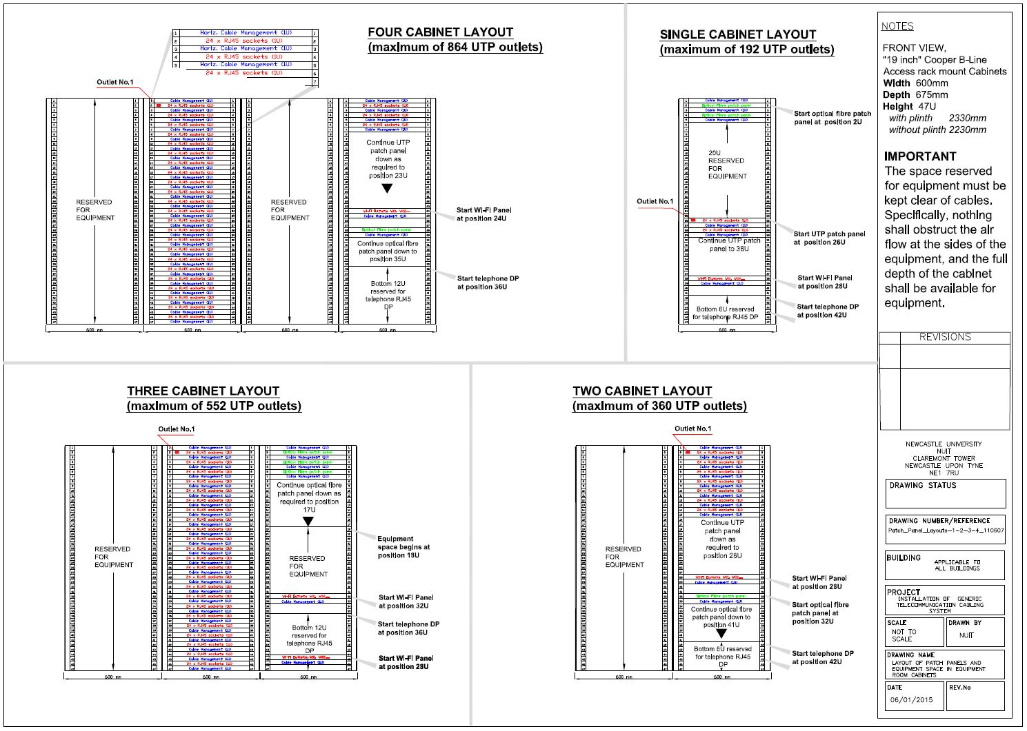

**APPENDIX 3 – High Density Patching Example**

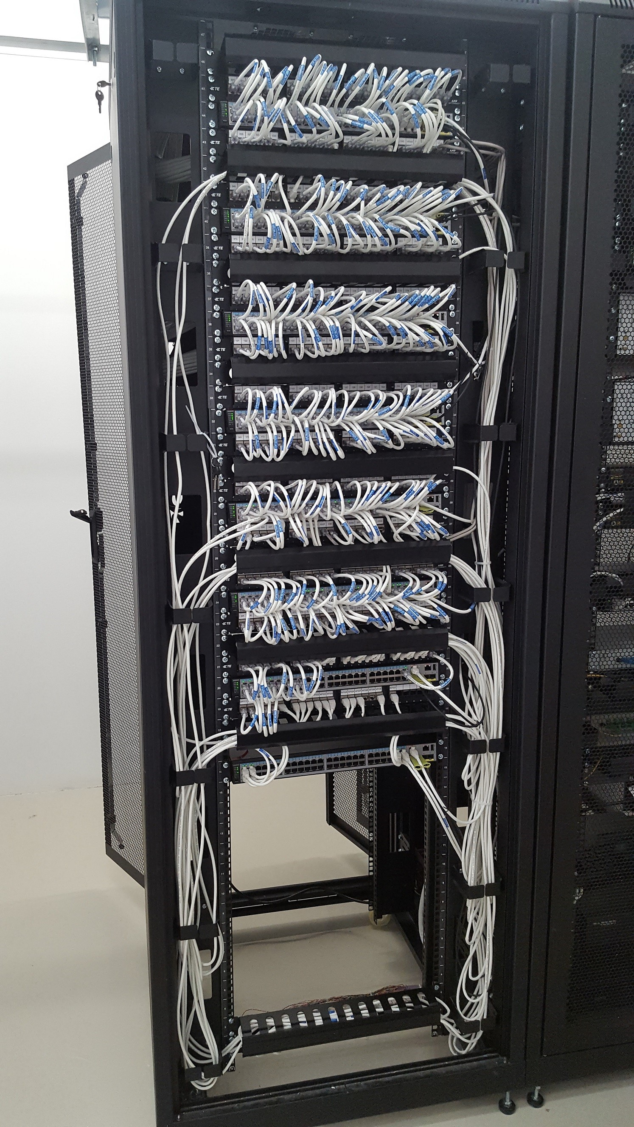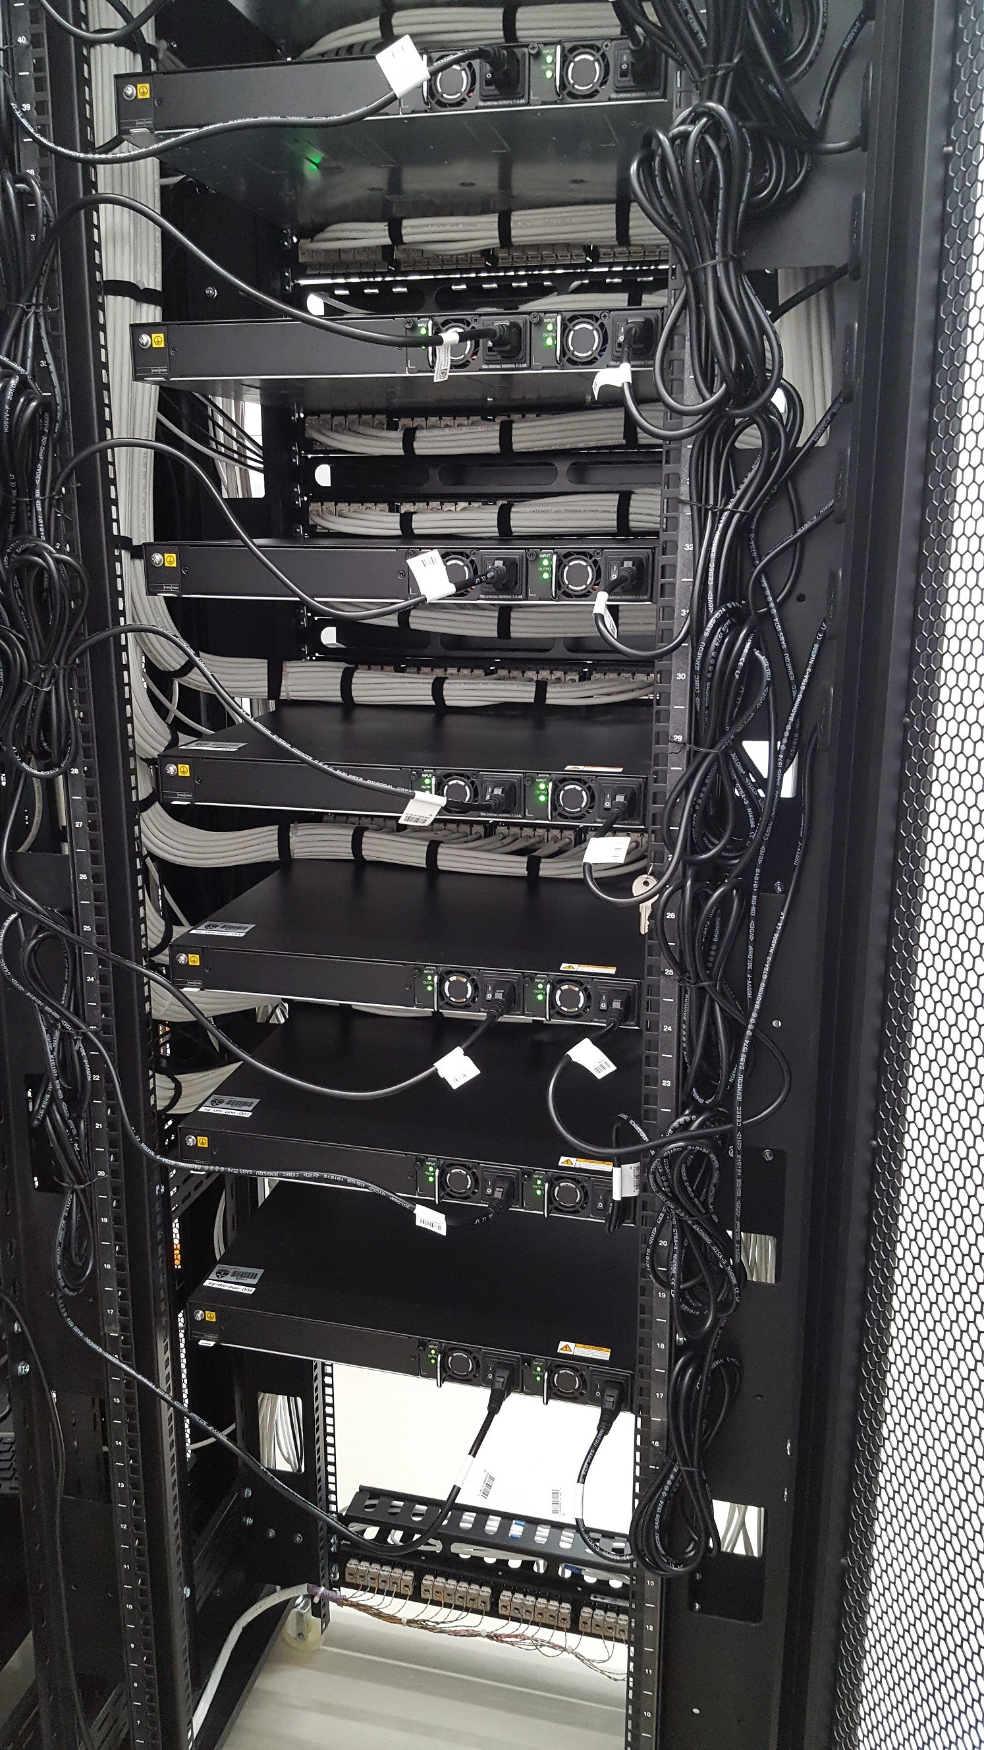

Please see the above images as an example of how the data cabling and switch hardware are interleaved at the front and rear of the **800mm wide** cabinet. Data cabling must be kept horizontal and parallel with the RJ45 patch panels to allow switches to be inserted between panels. Cabling harnesses at the rear of the cabinet must not impinge on the area between the rack uprights to allow switches to be installed through the full depth of the rack

Outlets in the 24-way patch panel **ABOVE** the switch WILL be patched into the **TOP** row of outlets on the 48-port switch

Outlets in the 24-way patch panel **BELOW** the switch WILL be patched into the **BOTTOM** row of outlets

On the 48-port switch as shown in these photographs

Telephone outlets in the bottom of the rack WILL be routed via the cable management strips adjacent to

relevant patch panel outlets.

The contractor shall install M6 caged nuts in standard 1U configuration in the whole of the front 19 inch

rack of all the cabinets, and supply an equivalent number of M6 steel pan head 15mm long screws

**NOTE: It is essential that the UTP cabling must not impinge on the insertion of switches between**

**the UTP panels as shown in these photographs**

**Document History**

|  |  |  |  |  |  |
| --- | --- | --- | --- | --- | --- |
| **Version** | **Date** | | **Responsible** | **Reason for change** | **Section** |
| V4.04 | | 15/12/2016 | Andrew Fisher | Insert requirement for module outlet recovery | 2.05 |
| V4.04 | | 10/03/2017 | Andrew Fisher | Added Wireless outlet installation | 2.06 |
| V5.00 | | 14/07/2017 | Andrew Fisher | Module Faceplate profile requirement change | 2.02 |
| V5.00 | | 14/07/2017 | Andrew Fisher | No company information displayed on faceplates | 2.02 |
| V5.00 | | 14/07/2017 | Andrew Fisher | Dimension changes for data cabinets | 2.09.1 |
| V5.00 | | 14/07/2017 | Andrew Fisher | DECT Base Station fitting requirements | 2.12.6 |
| V5.00 | | 14/07/2017 | Andrew Fisher | Vertical cable management reduction 1U to each 6U | 2.10 |
| V5.00 | | 14/07/2017 | Andrew Fisher | 16A Power requirements for all data cabinets | 2.11.4 |
| V6.00 | | 18/07/2018 | Andrew Fisher | Preferred Cable Manufacturer | 1.01 |
| V6.00 | | 18/07/2018 | Andrew Fisher | Standards Regulation Update | 1.03 |
| V6.00 | | 18/07/2018 | Andrew Fisher | Lot 2 change to include Advantex as a Connectix installer | 5.02 |
| V6.00 | | 18/07/2018 | Andrew Fisher | Smartcard Access Control requirement | 2.11.6 |
| V6.00 | | 18/07/2018 | Andrew Fisher | Patch lead colour requirements | 2.08 |
| V6.00 | | 18/07/2018 | Andrew Fisher | High Density Patching Detail | Appendix 3 |
|  | |  |  |  |  |
|  | |  |  |  |  |
|  | |  |  |  |  |
|  | |  |  |  |  |